Bug Report

ID number* | 46
Title* | Shopping cart icon on Shopping cart page - the position is not in the top-right corner
Reporter* | Mădălina Dămoc
Submit Date | 03/05/2024
URL | https://www.saucedemo.com/
Platform | Windows
Operating System | Windows 10 Pro
Browser | Chrome Version 123.0.6312.86 (Official Build) (64-bit)
Severity* | S4
Assigned to | /
Priority* | P4

Description
In Shopping cart page the shopping cart icon is not in the top-right corner, but slightly moved towards the center and a bit down.

Steps to reproduce
1. access site www.saucedemo.com in Chrome
2. insert valid data in field “Username” (visual_user)
3. insert valid data in field “Password” (secret_sauce)
4. press “Login” button
5. press “add to cart” for two products
6. click the icon off the cart

Expected result
In Shopping cart page the shopping cart icon is in the top-right corner.

Actual result
In Shopping cart page the shopping cart icon is not in the top-right corner, but slightly moved towards the center and a bit down (seems to be left-aligned with sort button).

Notes
The position of the shopping cart icon is the same (slightly moved towards the center and a bit down) in all pages: Home page, Single product page, Shopping cart page, Checkout page, Checkout overview page, Checkout complete page.

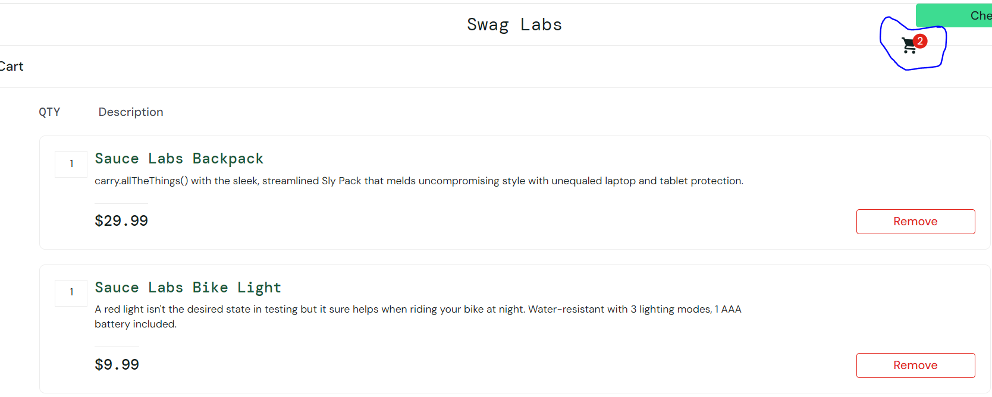
Actual result
Expected result

